Science By doing
- Go to 4.1, “notebook” and review vocabulary by clicking on ‘hydrological cycle’.
- Under 4.2, what are the seven parts of the ‘urban water cycle’? list and explain

- Under 4.3, list the five steps in water filtration and write one sentence summarising each process.

- Read through the information on Science By Doing 4.4
- Where is the water from Mpwelarre from?
__________________________________________________________________________________
- Where is the water from Katoomba from?
__________________________________________________________________________________
- Which would you expect to be healthier and why?
__________________________________________________________________________________
__________________________________________________________________________________
__________________________________________________________________________________
- Under ‘find out more’, which are the 4 main things they test for?
M________________________________________
P_________________________________________
C_________________________________________
R_________________________________________

- What does an aquatic ecologist measure? Under 4.5 go to “find out more” and fill in the blanks
Dissolved oxygen
Measures the amount of oxygen in the water. Very high or very low levels can affect organisms and indicate an unbalanced or unhealthy waterway.
pH
Measures __________/___________of the water. Highly acidic or alkaline waters can be toxic to aquatic organisms.
Turbidity and suspended solids
Turbidity is a measure of the ____________ of the waterway. Total suspended solids measure the amount of particles ______________ in the water. Small suspended particles of soil and organic matter are naturally present in all waters. In high concentration they reduce the _______________ of light (which is necessary for plants), or the particles can settle and smother aquatic organisms.
Nitrogen and Phosphorous
These are among the most important nutrients for plant growth. Concentrations are generally _______ in natural waterways, but are dramatically increased by some human activities. Very high concentrations of nutrients cause excessive plant growth and an increased spread of weeds and ________________.
Chlorophyll-a
This is a green pigment found in most plants including __________. It is an indicator of micro algal ____________. High concentrations occur in algal blooms which indicate poor ecosystem health.

Extension: Use the following table to answer the questions
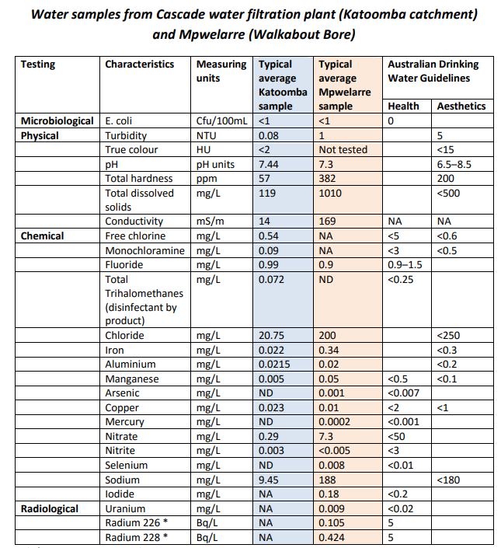
- Circle the values which exceed the Australian Water Drinking Guidelines.
- Which water is healthier and what might be some reasons why?

_______________________________________________________________________________________
_______________________________________________________________________________________
_______________________________________________________________________________________
_______________________________________________________________________________________

- Choose three of these values to investigate further and research why they have a guideline in place (i.e. what are the health impacts if it is not controlled).
Water quality measure | Why it is controlled

